

**PLACEMENT DATABASE FOR THE NORTHCAP UNIVERSITY**

**Course Name – Programming for Data Science**

**Course Code – CSL 225**

**Faculty Name – Dr. Rita Chhikara**

**Students Name and Roll Numbers – Aarushi Dua(18csu002)**

**Abhishek Bhatia(18csu008)**

**Bhavya Kalra(18csu045)**

**Project Title: PLACEMENT DATABASE**

**Description of Project:**

Placement Database is a project based on the GUI. This is a project based on the visual representation of Placement done in the NorthCap University throughout the years 2015-2016, 2016-2017 and 2017-2018 using pandas, matplotlib and numpy library and packages.

**Problem Statement:**

The problem is to find the differences between the recruiting done between the years. It is easier to maintain and view or explain the databases or records of the data stored in different tables in a single format for anyone, keeping that thing in mind, we have created an efficient system which will display the visual representation of the PLACEMENT DATABASE hence making the things easy for even an non-technical person to understand the Data. Also saving the details of the latest placement records it will be easy to show maximum, average packages and graphical representation of top ten companies.

**Problem Analysis:**

The issue of the program is to showcase differences between placements done in the years and to show the details of latest placement done in the university. The other problem is to make the visualization very clear and easier for the user to read.

**Program Design:**

**Programming Requirements:**

The programming requirement for the program are very few as the plotting and detailing done is all to be seen and not to be operated on by the user(apart from some commands).

**Data/Input Output Description:**

The project is based on visual representation of the given placement data so the programming is made by using numpy, pandas, matplotlib library and packages. The output can be seen in various types such as list DataFrame and graphs.

**Algorithmic Approach/Algorithm/DFD/ER diagram/Program Steps:**

**Implementation and Testing:**

**INPUT1:**

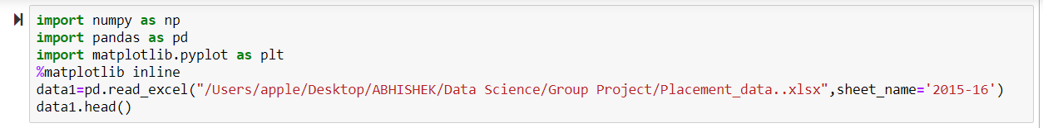

**>THE ABOVE CODE IS USED TO DISPLAY THE CONTENT OF EXCEL SPREADSHEET FILE WITH THE HELP OF READ_EXCEL METHOD IN PANDAS.**

**> HEAD IS BEING USED TO DISPLAY THE TOP 5 CONTENT OF THE SPREADSHEET.**

**OUTPUT1:**

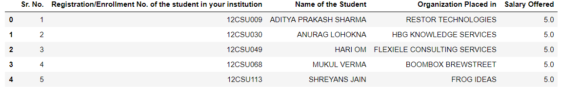

**INPUT2:**



**>DROP_DUPLICATES METHOD IS USED TO DELETE THE DUPLICATE VALUES IN A LIST OF SET. HERE WE ARE SHOWING THE NAMES OF THE COMPANIES WHICH CAME FOR RECRUITMENT FOR THE PARTICULAR YEARS.**

**OUTPUT2:**

0 RESTOR TECHNOLOGIES

1 HBG KNOWLEDGE SERVICES

2 FLEXIELE CONSULTING SERVICES

3 BOOMBOX BREWSTREET

4 FROG IDEAS

5 MEDMAP

6 PANACEA HEALTHCARE

7 MUNICIPAL CORPORATION GURGAON

9 DHRUV INTERIORS

12 AUTHBRIDGE

13 AAR CEE CONTRACTS

14 PROPTIGER

16 JAINCO

20 SOCIAL CURRY

21 HCL TECHNOLOGIES

22 ICAT

23 DIFFERENTIAL TECHNOLOGIES

25 GLOBALLOGIC

26 NINE DOT NINE MEDIAWORX

28 ULTIMATE SUN SYSTEMS

29 AKASHDEEP COLD STORAGE

30 VASUTECH AUTOMATIONS

31 PICK A HOME

33 BOONESS SERVICES

34 JEEVANSONS PUBLICATIONS

35 ASAAN E-COMMERCE

37 TIMES INTERNET LTD.

41 TALENT4ASSURE CONSULTING SERVICES

42 VISHESH TECHNOLOGIES

44 BLISSANANO

...

54 TCS

57 ORANGE BUSINESS SERVICES

107 ORANGE

161 MANDO SOFTTECH INDIA

165 CITY HABITAT

166 SKC INFRATECH

168 RELIANCE

174 GURU RAM DASS (AUTOMOBILE BODY BUILDERS)

175 NEWGEN SOFTWARE TECHNOLOGIES

195 ORKASH

196 EDYNAMIC

197 EDYNAMIC

208 GLOBUS EIGHT

218 EY GLOBAL DELIVERY NETWORK INDIA

242 DENSO

247 LIBSYS

254 HR POLYCOT

255 SEAFARRADAY

256 WACOM INDIA

257 SAPIENT

274 FIDELITY

286 INSIGHT PLM CONSULTING

288 CB & I

293 EXPEDITORS INTERNATIONAL

294 HONDA CARS INDIA

298 S&P CAPITAL IQ

301 DAIKIN

303 GEMINI SOLUTIONS

315 DELOITTE

350 MENTOR GRAPHICS

Name: Organization Placed in, Length: 64, dtype: object

**INPUT3:**



**>MEDIAN IS THE BEST WAY TO FIND THE AVERAGE SALARY BEING OFFEREDE BY THE COMPANIES RECRUITING.**

**OUTPUT3:**



**INPUT4:**

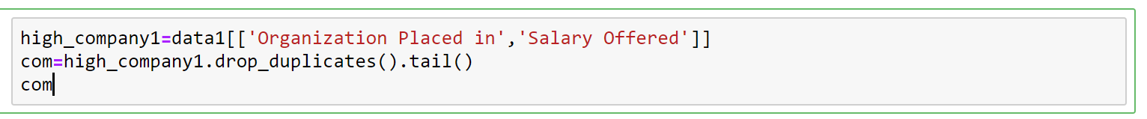

**>HERE THE PARTICULAR COLUMNS (ORGANIZATION PLACED IN AND SALARY OFFERED )FROM DATA1(DATASET) ARE BEING SAVED IN NEW DATASET HIGH_COMPANY1.**

**> TAIL IS BEING USED TO DISPLAY 5 COMPANY NAME AND SALARY OFFERED FROM THE END.**

**OUTPUT4:**

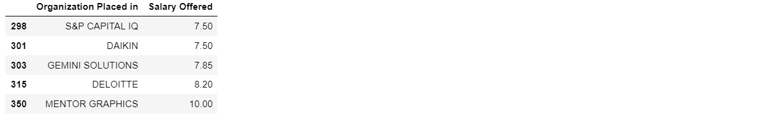

**INPUT5:**

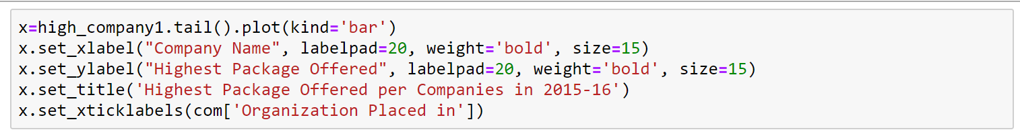

**>HERE MATPLOTLIB IS BEING USED TO PLOT BAR GRAPH BETWEEN COMPANY NAME AND HIGHEST PACKAGE OFFERED.**

**OUTPUT5:**

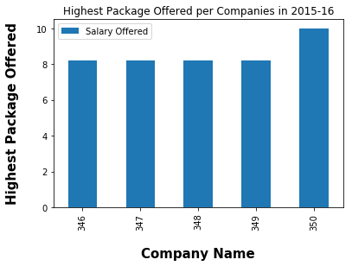

**INPUT6:**

**>NEW DATASET TOP_COMAPNY IS BEING IS USED TO SAVE DATA OF ORGANIZATION PLACED IN FROM DATASET DATA1. VALUE COUNTS IS BEING USED TO COUNT THE VALUE OF THE APPEARANCES TAKING PLACE.**

**OUTPUT6:**

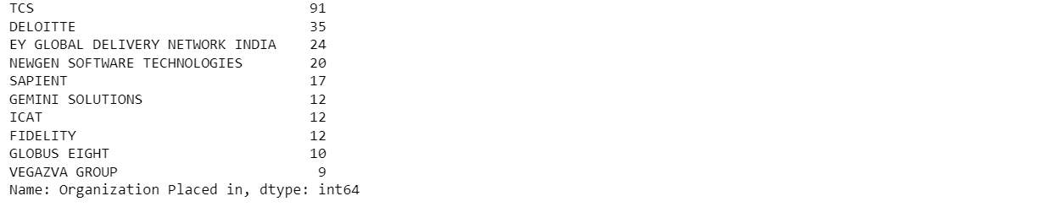

**INPUT7:**



**>HERE TOP 10 FROM ABOVE IN TOP_COMPANY DATASET ARE BEING PLOTTED IN A BAR GRAPH BETWEEN STUDENTS PLACED AND COMPANY PLACED IN.**

**OUTPUT7:**

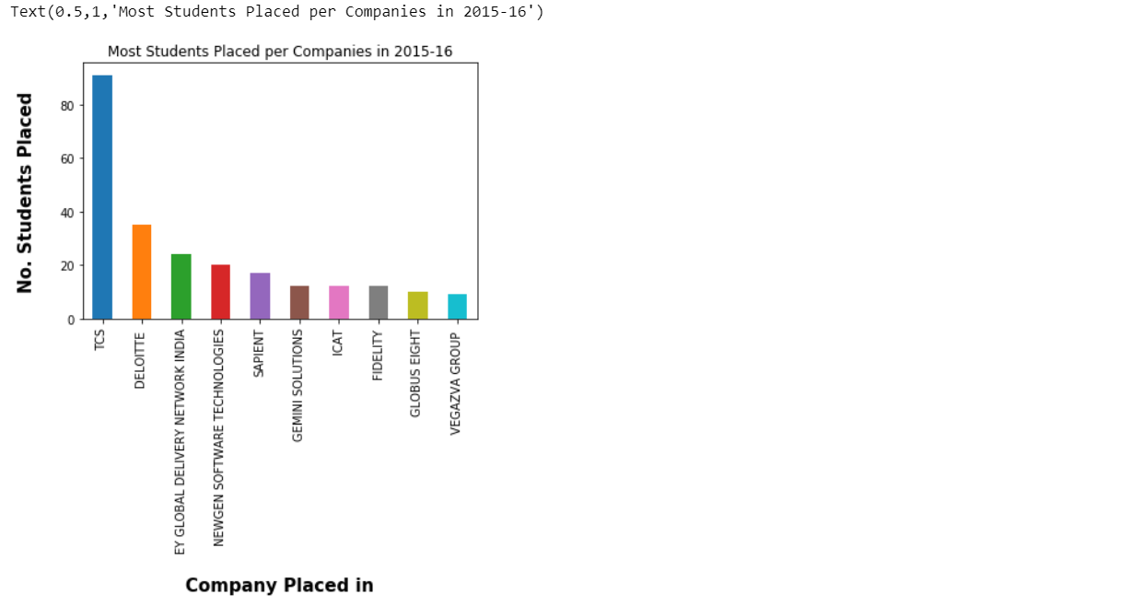

**INPUT8:**

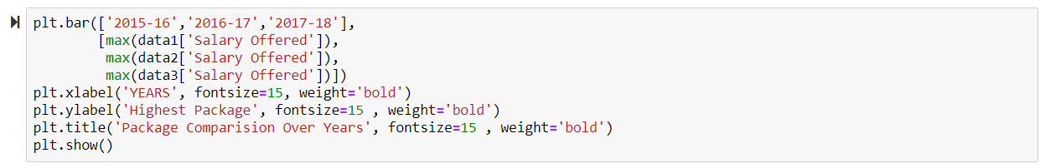

**>HERE THE A BAR GRAPH IS BEING PLOTTED BETWEEN HIGHEST SALARY BEING OFFERED THROUGHOUT THE YEARS: 2015-16, 2016-17 AND 2017-18**

**OUTPUT8:**

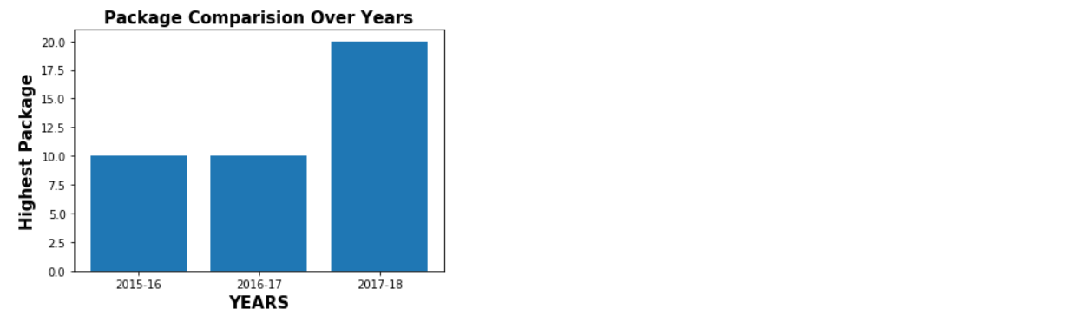

**INPUT9:**

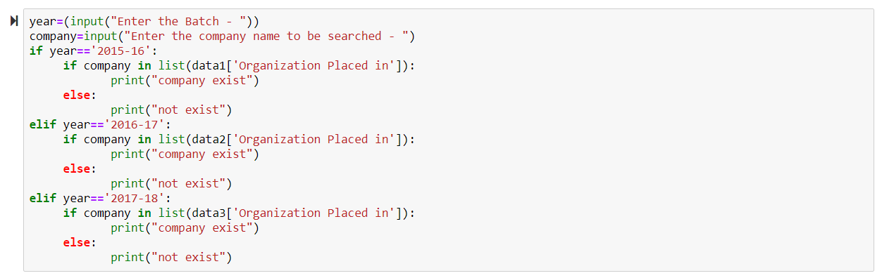

**OUTPUT9:**

